Mini Project Report
Customer Segmentation Using K-Means Clustering
Machine Learning | SY B.Tech AIML
Name: Manaswi Vishal Sorde
PRN: 248109059

Project Title | Customer Segmentation Using K-Means Clustering
Domain | Machine Learning / Data Science
Algorithm Used | K-Means Clustering
Dataset | Mall Customers Dataset (Kaggle)
Tools & Libraries | Python, pandas, NumPy, scikit-learn, seaborn, matplotlib
IDE / Platform | Kaggle Notebook

1) Background / Problem Statement

In the modern business landscape, companies collect vast amounts of customer data — including age, annual income, and spending behaviour. However, without proper analysis tools, this data remains underutilised and businesses struggle to identify distinct customer groups for targeted marketing strategies.

Customer segmentation is the process of dividing a company's customers into groups based on shared characteristics. This allows businesses to:
- Target marketing campaigns more effectively
- Personalise product recommendations
- Allocate resources efficiently
- Improve customer satisfaction and retention

This project introduces a Customer Segmentation System using K-Means Clustering — an unsupervised machine learning algorithm — to automatically group mall customers based on their Annual Income and Spending Score. By identifying these clusters, businesses gain actionable insights for data-driven decision making.

2) Working of the System

The system follows a structured pipeline to load, preprocess, analyse, and visualise customer data using the K-Means clustering algorithm. The key stages are:

Step 1 — Data Loading & Exploration
The Mall Customers CSV dataset is loaded using pandas. Initial exploration steps include:
- Displaying the first few rows with head() to understand the structure
- Checking dataset dimensions using shape
- Reviewing column data types and null values using info() and isnull().sum()

Step 2 — Feature Selection
Two key features are selected for clustering:
- Annual Income (column index 3)
- Spending Score (column index 4)
These two features best represent customer purchasing behaviour and financial capacity, making them ideal for segmentation.

Step 3 — Determining Optimal Clusters (Elbow Method)
The Within-Cluster Sum of Squares (WCSS) is computed for cluster counts ranging from 1 to 10. WCSS measures the compactness of clusters — a lower value indicates tighter, better-defined clusters. The results are plotted to produce the Elbow Graph, where the point of maximum curvature (the elbow) indicates the optimal number of clusters.
From the graph, the optimal number of clusters is determined to be 5.

Step 4 — K-Means Model Training
The K-Means model is trained with 5 clusters using the k-means++ initialisation strategy (which improves convergence speed and accuracy) and a fixed random seed for reproducibility. Each customer data point is assigned a cluster label.

Step 5 — Cluster Visualisation
All 5 clusters are plotted on a 2D scatter plot with distinct colours. Cluster centroids (computed means of each group) are marked in black. The axes represent Annual Income (X-axis) and Spending Score (Y-axis), giving a clear visual overview of each customer segment.

3) Methodology

The project follows a clean, step-by-step data science pipeline:

1 | Import Libraries  numpy, pandas, seaborn, matplotlib, sklearn.cluster.KMeans
2 | Load Dataset  pd.read_csv() — Mall_Customers.csv (CustomerID, Genre, Age, Annual Income, Spending Score)
3 | Exploratory Data Analysis (EDA)  head(), shape, info(), isnull().sum() — Inspect structure, types, and missing values
4 | Feature Selection  Select Annual Income (col 3) and Spending Score (col 4) as input features x
5 | Elbow Method (Optimal K)  Compute WCSS for k=1 to 10, plot Elbow Graph — identify k=5 as optimal
6 | Train K-Means Model  KMeans(n_clusters=5, init='k-means++', random_state=0), fit_predict(x)
7 | Visualise Clusters  Scatter plot with 5 colour-coded groups + black centroids; labelled axes

4) Code

4.1 — Import Libraries
import seaborn as sns
import matplotlib.pyplot as plt
from sklearn.cluster import KMeans
import numpy as np
import pandas as pd

4.2 — Load Dataset
customer_data = pd.read_csv("/kaggle/input/datasets/moonlawlier/customer-dataset/Mall_Customers.csv")
print(customer_data.head())
customer_data.shape
The dataset contains 200 customer records with 5 columns: CustomerID, Genre, Age, Annual Income (k$), and Spending Score (1–100).

4.3 — Exploratory Data Analysis (EDA)
customer_data.info()
customer_data.isnull().sum()
This confirms the data types, number of entries, and verifies there are no missing values in the dataset.

4.4 — Feature Selection
# Select Annual Income and Spending Score columns
x = customer_data.iloc[:, [3, 4]].values
print(x)
Only Annual Income and Spending Score are selected as they are the most relevant features for behavioural segmentation.

4.5 — Finding the Optimal Number of Clusters (Elbow Method)
wcss = []

for i in range(1, 11):
kmeans = KMeans(n_clusters=i, init='k-means++', random_state=42)
kmeans.fit(x)
wcss.append(kmeans.inertia_)

sns.set()
plt.plot(range(1, 11), wcss)
plt.title('The Elbow Point Graph')
plt.xlabel('Number of Clusters')
plt.ylabel('WCSS')
plt.show()
WCSS (Within-Cluster Sum of Squares) quantifies the compactness of clusters. As the number of clusters increases, WCSS decreases. The optimal K is where the rate of decrease sharply levels off — forming an 'elbow' shape.
Result: The elbow occurs at K = 5, confirming 5 is the optimal number of clusters.

4.6 — Training the K-Means Model
kmeans = KMeans(n_clusters=5, init='k-means++', random_state=0)

# Assign cluster labels to each customer
y = kmeans.fit_predict(x)
print(y)
The fit_predict() method trains the model and returns a label (0–4) for each data point, indicating which cluster they belong to.

4.7 — Visualising Customer Clusters
plt.figure(figsize=(8, 8))
plt.scatter(x[y == 0, 0], x[y == 0, 1], s=50, c='Crimson', label='Group 1')
plt.scatter(x[y == 1, 0], x[y == 1, 1], s=50, c='RosyBrown', label='Group 2')
plt.scatter(x[y == 2, 0], x[y == 2, 1], s=50, c='SlateGray', label='Group 3')
plt.scatter(x[y == 3, 0], x[y == 3, 1], s=50, c='CadetBlue', label='Group 4')
plt.scatter(x[y == 4, 0], x[y == 4, 1], s=50, c='DarkViolet', label='Group 5')

# Plot centroids
plt.scatter(kmeans.cluster_centers_[:, 0], kmeans.cluster_centers_[:, 1],
s=100, c='black', label='Centroids')

plt.title('Customer Groups')
plt.xlabel('Annual Income')
plt.ylabel('Spending Score')
plt.legend()
plt.show()

5) Output

Based on the scatter plot output, 5 distinct customer segments are identified:

Group | Annual Income | Spending Score | Description
Group 1 | Medium | Medium | Average customers — balanced spenders [Red]
Group 2 | High | High | Target customers — high earners who spend freely (VIPs) [Brown]
Group 3 | Low | High | Careless spenders — low income but high spending (risk of debt) [Purple]
Group 4 | High | Low | Conservative spenders — high earners who spend cautiously [Grey]
Group 5 | Low | Low | Careful customers — low income and low spending (budget-conscious) [Green]
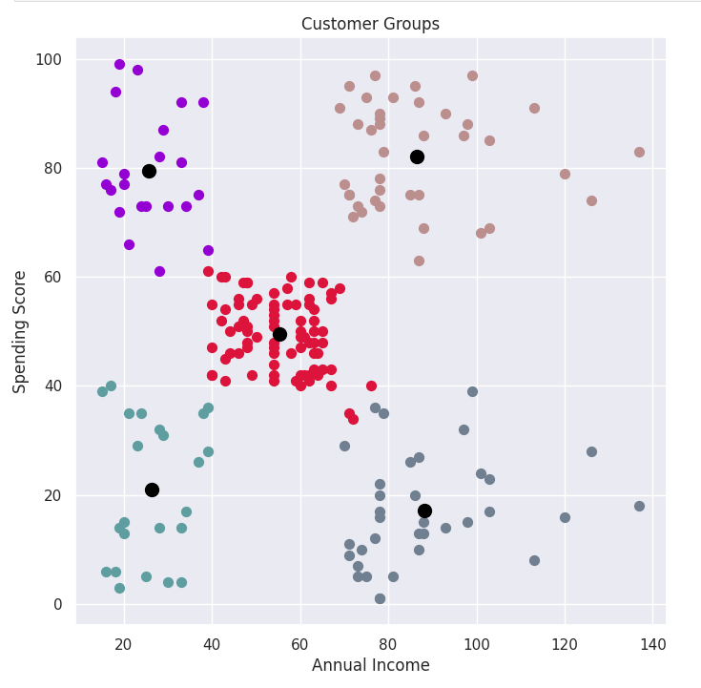

6) Video Link

https://drive.google.com/drive/u/2/folders/11Wz1jVLuRWVWNguUGkR38Tvw0ujoniq-

7) Advantages

- Unsupervised learning — no labelled data required; the algorithm discovers patterns automatically.
- Scalable — K-Means works efficiently on large datasets, making it suitable for real-world retail data.
- Interpretable results — the 2D scatter plot provides clear, human-readable cluster boundaries.
- Actionable marketing insights — enables targeted promotions for each distinct customer group.
- Fast training — K-Means with k-means++ initialisation converges quickly with minimal iterations.
- Reusable model — once trained, the model can classify new customers into existing segments instantly.

8) Limitations / Disadvantages

- K must be specified in advance — the number of clusters needs prior knowledge or the Elbow Method.
- Sensitive to outliers — extreme income or spending values can distort cluster centroids.
- Only 2 features used — results may differ with additional features like age or gender included.
- Assumes spherical clusters — K-Means struggles with irregular or non-convex cluster shapes.
- No probabilistic assignment — each customer is assigned to exactly one cluster with no confidence score.

9) Applications

- Retail & e-commerce: Personalised product recommendations and loyalty programme design.
- Banking & finance: Credit risk profiling based on income and spending patterns.
- Healthcare: Patient stratification based on lifestyle and medical expenditure.
- Telecommunications: Customer churn prediction and targeted retention offers.
- Hospitality: Hotel and restaurant customer grouping for personalised packages.

10) Conclusion

This project successfully demonstrates the application of K-Means Clustering — an unsupervised machine learning algorithm — to segment mall customers based on their Annual Income and Spending Score.

Using the Elbow Method, the optimal number of clusters was determined to be 5, each representing a distinct customer persona: target VIP customers, careless spenders, conservative high earners, average shoppers, and budget-conscious buyers. These segments provide businesses with data-driven foundations for personalised marketing, resource allocation, and strategic decision-making.

The project demonstrates key data science skills including exploratory data analysis, feature selection, unsupervised model training, hyperparameter tuning, and result visualisation — all implemented using standard Python libraries.

11) References

- Mall Customers Dataset — Kaggle (https://www.kaggle.com/)
- scikit-learn Documentation — KMeans Clustering (https://scikit-learn.org/)
- Pandas Documentation — (https://pandas.pydata.org/)
- Seaborn Documentation — Statistical Data Visualization (https://seaborn.pydata.org/)
- K-Means Clustering Explained — Towards Data Science (https://towardsdatascience.com/)

12) System Requirements

Hardware Requirements
- Laptop or PC with Windows 7 or higher / macOS / Linux
- Processor: Intel Core i3 or higher
- RAM: 4 GB or higher
- Storage: 10 GB or higher

Software Requirements
- Python 3.7 or higher
- Libraries: numpy, pandas, scikit-learn, seaborn, matplotlib
- IDE: Jupyter Notebook / Kaggle Notebook / VS Code
- pip (Python package manager)

Installation Commands
pip install numpy pandas scikit-learn seaborn matplotlib

